Simple Factory

Creational Design Pattern

**What problems does Simple Factory solve:**

1. Multiple types can be instantiated and the choice is based on some simple criteria.

**What is Simple Factory:**

1. Move the instantiation logic to a separate class.
2. Encapsulates object instantiation.
3. Allows reuse of the simple factory by other classes without importing unrelated classes.

**UML:**

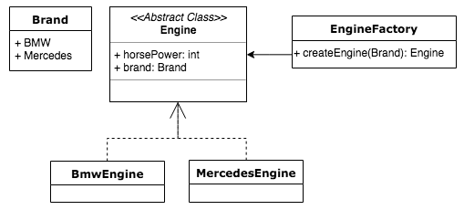

**Difference with Factory Method:**

Simple Factory:

1. Move instantiation logic away from client code.
2. Knows about all classes whose objects it can create

Factory method:

1. Delegate object creation to subclasses
2. Doesn’t know in advance about all product subclasses

**Implementation:**

1. Create an interface (Post).
2. Create concrete classes for the interface (ProductPost, BlogPost, etc.).
3. Create a factory that return a Post. (PostFactory).